Lab #5 Pre-lab Reading and Quiz – Parallax

Parallax
One of the most frustrating problems in astronomy is trying to figure out how far away things are. We’re really good at measuring angles, but these angles can be translated into real sizes only when we know how far away the objects are. Thus, while it’s pretty easy to measure that Venus has an angular diameter of, say, 11'', we can’t calculate its linear diameter until we know the distance to Venus. (Recall that 11'' is a shorthand way of saying 11 arcseconds and that an arcsecond is 1/60th of an arcminute, which is in turn 1/60th of a degree.) Since many physical properties (e.g., mass, density) depend on the actual physical size of an object, it’s important to have some idea of how far away astrophysical objects are.
The Observer's Triangle -- A Review
As you know well by now, astronomers make use of the “Observer’s Triangle” when converting angles to distances. Consider the figure below, which shows the geometry for an observer (on the left) measuring the angular size of some object (e.g., a planet).

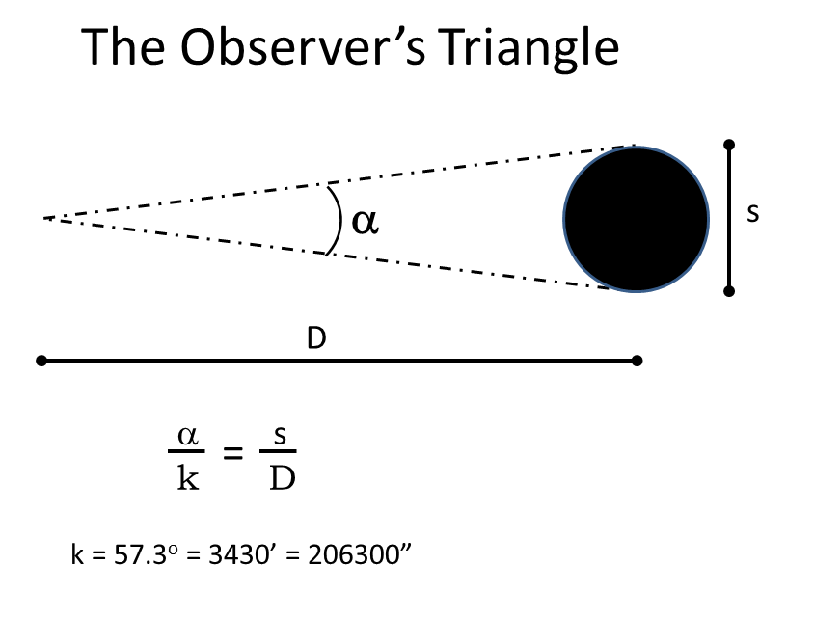
The observer can directly measure the angular size, and if she knows the distance (d) to the object, she can calculate its size (s) using our well-worn Observer's Triangle formula above, where the constant k depends on the units of the angular size.
So, for example, if we measure Venus to have an angular size of 11'', and we know that the planet has a diameter of 12000 km, we can directly calculate its distance from us using the Observer's Triangle. (You should make sure you can do this before you take the pre-lab quiz. Answer: 2.2 x 10⁸ km)
Measuring Larger Distances
As we have learned in class, we can't measure the distances to faraway stars by looking at their angular sizes, mainly because their angular sizes are too small to measure accurately. That is, most stars are just pinpoints of light. Essentially, we need s (in the Observer's Triangle equation) to be bigger because d is so huge. One way to achieve this is to turn the long skinny triangle around and use parallax measurements. With parallax, a person can determine the distance to an object by seeing how much its position appears to shift with respect to that of distant objects in the background, as measured from two places a known distance apart (the known distance is called the baseline for the parallax measurement). We make use of the fact that we're moving through space over the course of the year, to observe stars from two different locations. The figure below shows the geometry for a parallax measurement of a relatively nearby star:

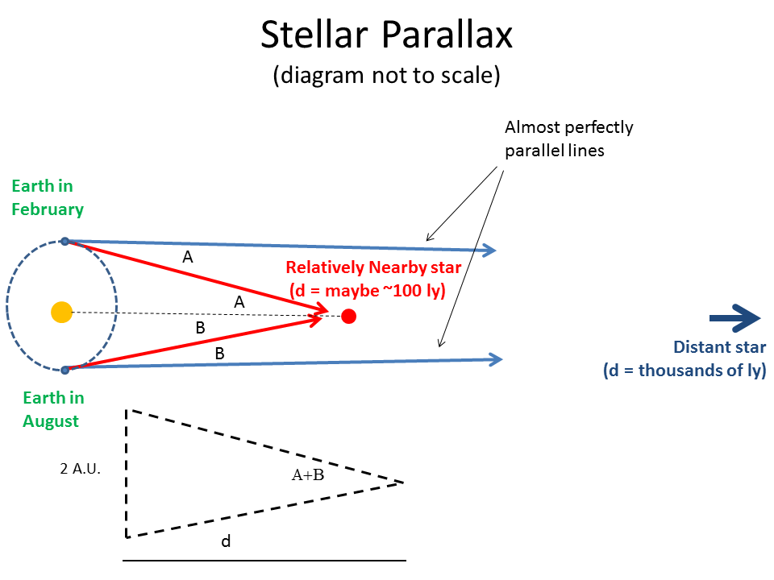
Two observations made six months apart will also be made from locations separated by twice the Earth's orbital radius, or 2 A.U. If we can measure by how much a relatively nearby star appears to move (of course, it's not really moving) we can determine its distance from us.
An observer viewing a nearby star in February would see that star to the right side of a very distant star, while six months later, in August, the star would appear to the left side of the distant star. The star would appear to move back and forth on the sky; this apparent motion is called the parallax motion. We define the parallax angle, p, as half the total angular motion of the nearby star relative to the background stars.
We can measure parallax angles, and geometry gives us the distance. Applying the Observer’s Triangle for this special case of parallax, we get:

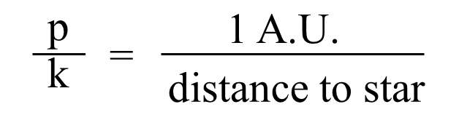
Parallax angles are usually measured in arcseconds. Since the distances to even the nearest stars are so great, it is inconvenient to use A.U. for the distance unit. Instead, we define a new unit called the parsec, where 1 parsec = 206,300 A.U. This new distance unit greatly simplifies the Observer's Triangle for parallax:

Distance (in pc) = 1/p(in arcseconds)
Keep in mind that in this simplified equation, the parallax angle p must be measured in arcseconds, and the distance that results is in units of parsecs.
This week's lab focuses on how we go about measuring the parallax angle, which sometimes can be tricky.

1. An observer in Cape Town, South Africa observes the star Alpha Centauri to be 1.2 arcseconds east of a fainter and much more distant background star. Six months later, the same Cape Town observer measures Alpha Centauri to be 2.72 arcseconds east of the same fainter star.
What is the parallax angle of Alpha Centauri?
Select one:
a. 0.76 arcseconds
b. 3.92 arcseconds
c. 1.52 arcseconds
d. 1.96 arcseconds

2. A giant glowing gas cloud near the Great Nebula of Orion has a size of 10 pc. If it also has an angular size of 69 arcminutes, how far away is this cloud?
Select one:
a. 500 pc
b. 10 pc
c. 250 pc
d. 145 pc

3. Sirius, the brightest star in the nighttime sky, is located 2.6 pc from us. What's its parallax angle?
Select one:
a. 0.38 arcseconds
b. 0.19 arcseconds
c. 0.76 arcseconds
d. 2.6 arcseconds

4. The planet Uranus has an angular size of 4", and it's located 2.59 billion km from Earth. What is the radius of this planet?
Select one:
a. 25100 km
b. 50200 km
c. 9.1 x 10⁷ km
d. 1.5 x 10⁶ km

