Laboratory

5

Name:___________________________________

Lab Meeting Date/Time: ____________________

Parallax Measurements

Stars are currently too distant for travel, and so we cannot measure distances to stars using, say, a very long tape measure. We use instead the parallax effect resulting from our motion around the Sun. Over the course of a year, we view relatively nearby stars from different positions as we complete an orbit.

## Part 1 – A WWT Tutorial

The first part of this lab involves the WorldWide Telescope (WWT), a multi-perspective visualization tool developed by Microsoft Research. We will use it to see and measure parallax effects for nearby stars. The software involves both video and audio output, so be sure that your computer’s audio output is not muted, and have your ear buds plugged in. As you work through the interactive “tour,” follow along with this writeup and record your notes and responses when prompted.

To launch the activity, double-click on the Shortcut “Parallax Prelab” in \Departments\Physics\Public\Astronomy\WWT\.

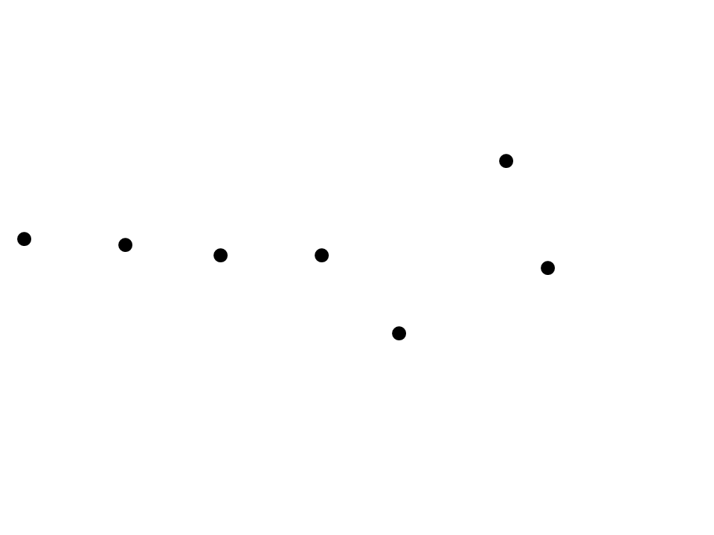**Tour Portion: Big Dipper Exploration**

Which is the most distant star? (circle the star in the diagram at right)

How do you know?

**Tour Portion: The View from the Green Star**

In what ways does the Big Dipper look different from this vantage point?

**Tour Portion: Quantifying Angular Separations (BD Star A)**

From the perspective of our Solar System (the yellow dot):

Angular separation between BD Star A and the distant red star (A1):____________

From the perspective of your friend’s star system (the green dot):

Angular separation between BD Star A and the distant red star (A2):____________

The change in the angular separation (i.e., how much the blue star appeared to move between the two perspectives):____________________________

If BD Star A were farther away, would the difference between the angular separations be greater or smaller?

______________________

**Tour Portion: Quantifying Angular Separations (BD Star B)**

From the perspective of our Solar System (the yellow dot):

Angular separation between BD Star B and the distant red star (B1):____________

From the perspective of your friend’s star system (the green dot):

Angular separation between BD Star B and the distant red star (B2):____________

The change in the angular separation (i.e., how much the blue star appeared to move between the two perspectives – *be careful here; there’s a trap!*):____________________________

For which star is there a greater change in angular separation? BD Star A BD Star B

Which star is the more distant? BD Star A BD Star B

## 

## Part 2 – Parallax on Campus

Since we don’t have a year to complete this laboratory experiment, we’ll instead practice parallax measurements on lampposts located on campus. The measurement techniques are identical to those used for measuring the distances to stars. In place of astronomical telescopes, we’ll use surveyor’s transits, which are effectively precision terrestrial telescopes.

Your instructor and TAs will teach you how to use the transits out in the field. You’ll make use of both scales on the transit: the azimuth scale, which measures angles around the horizon (side-to-side), and the altitude scale, which measures angles above and below the horizon (up-and-down).

## Procedure – Data Collection

We will set up our experiment in a large lawn on campus with multiple lampposts and a clear view of a distant reference object. Pick a spot to set up, making sure you can see the reference object and two lampposts (one near, one far). The reference object will play the role of a distant background star in our experiment. You will be provided with a 2 meter length of string to use as a baseline. We will use this string to define a circular “orbit” around a fixed point in the grass (the “Sun”). Thus in our model, the radius of the “Earth’s” orbit will be 2 meters.

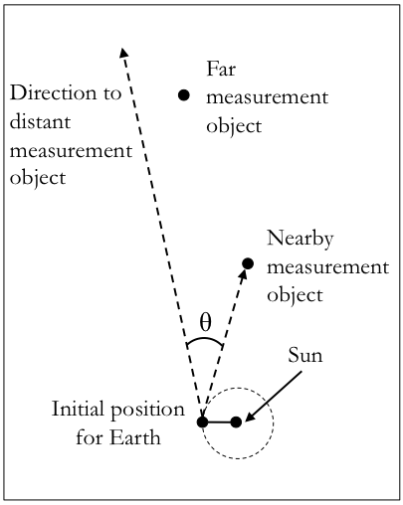We will use our parallax technique to measure the distance to a couple of lampposts between your location and a distant reference object. These lampposts will serve as the nearby stars for our model. We will measure the amount these “stars” appear to shift (relative to the distant steeples) and use that information to determine their distances.

Let’s get started:

1. Set the location of the “Sun” by placing the pizza tin on the ground and securing it in place with a tent peg through the center hole.
2. Place one of the rings at the end of the 2-m string over the tent peg, and use the other end to define a circle around the Sun; this is the orbit of the Earth.
3. Chose a location in the Earth’s orbit such that the angle between the nearby star, Sun, and Earth is roughly 90o. This will be your starting position for the parallax measurements. Set your transit so that it’s positioned directly over this location. Note the “month” of the observations as indicated by the lines on the pizza tin.
4. Measure the angular separation between the reference object and the nearby lamppost. These measurements rely on high accuracy; take your time and measure very carefully! We define angles to the left of the reference object to be negative (−), and angles to the right as positive (+); this is just an arbitrary convention, but we need to make sure we’re consistent. Record this measurement in the table on the next page.
5. Repeat this measurement for the more distant lamppost, and record that angular separation in the third column of the appropriate row in the table on the next page.

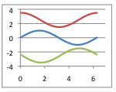Repeat this procedure for *six locations in the Earth’s orbit, each two months apart*. Record the measurements in the relevant rows of the table on the next page.

When you’ve completed your measurements, plot your data (angular separation vs. month) for both the nearby and farther away lampposts in the spaces provided on pages 6 and 7. Draw a smooth curve through your data. The curve should look like a *sine* curve, with one “peak” and one “valley.”

|  |  |  |
| --- | --- | --- |
| **Month** | **Angular Separation for Nearby Lamppost**  **(degrees)** | **Angular Separation for Far Lamppost**  **(degrees)** |
| January |  |  |
| February |  |  |
| March |  |  |
| April |  |  |
| May |  |  |
| June |  |  |
| July |  |  |
| August |  |  |
| September |  |  |
| October |  |  |
| November |  |  |
| December |  |  |

**(Note: Record observations for six “months,” each two months apart, Choose your months wisely, so you can observe the maximum change in angular separation!)**

Angular Separation Between Near Lamp Post and Distant Reference Object



Angular Separation Between Far Lamp Post and Distant Reference Object



## Procedure – Distance Measurements

Now, let us analyze the graphs that you’ve created.

Describe in your own words what quantities have been plotted.

How does the angular separation change with time?

In what month is the angular separation greatest for the near lamppost? For the far lamppost?

In what month is the angular separation smallest for each lamppost?

Identify the two “months” you would choose to observe in order to measure the *maximum change in the angular position* of the nearby lamppost.

|  |  |
| --- | --- |
| Month of First Observation |  |
| Month of Second Observation |  |

What is the change in the angular position of the lamppost over this interval? ________

What is the physical separation between the locations of the two observations?________

Draw an “overhead view” diagram indicating the positions of these two observations, the nearby lamppost, and the distances and angular separations we just discussed (Hint: it should look like a triangle).

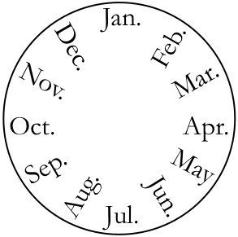

Use your knowledge of long skinny triangles to determine the distance to the nearby lamppost.

**Now repeat your analysis for the more distant lamppost:**

Identify the two “months” you would choose to observe to measure the *maximum change in the angular position* of the far lamppost.

|  |  |
| --- | --- |
| Month of First Observation |  |
| Month of Second Observation |  |

What is the change in the angular position of the lamppost over this interval? ________

What is the physical separation between the locations of the two observations?________

Draw a diagram indicating the positions of these two observations, the far lamppost, and the distances and angular separations we just discussed (Hint: it should look like a triangle)

Use your knowledge of long skinny triangles to determine the distance to the far lamppost.

**Analysis**

Question**:** Based on your analysis above, which distance measurement do you think is more accurate, the measurement of the distance to the near lamp post, or the far one?

What about the measurements and analysis leads you to this conclusion?

Now that we have the distances to the lampposts, we can use the Observer’s Triangle to calculate their **height**. Using the vertical (altitude) scale on your transit, measure the angular size of each lamppost as viewed from the position of the Sun. Calculate the height of the lamppost using the angular size that you measured and the parallax distance you calculated above.

Calculations:

Height of near lamppost:_____________ Height of far lamppost:______________

Question**:** Based on your analysis above, which lamppost height measurement do you think is more accurate, the measurement of the height of the near lamppost, or the far one?

What about the measurements and analysis leads you to this conclusion?